Name: Laiba Asim
Sap id: 65230

Lab 8:

Example code 1:

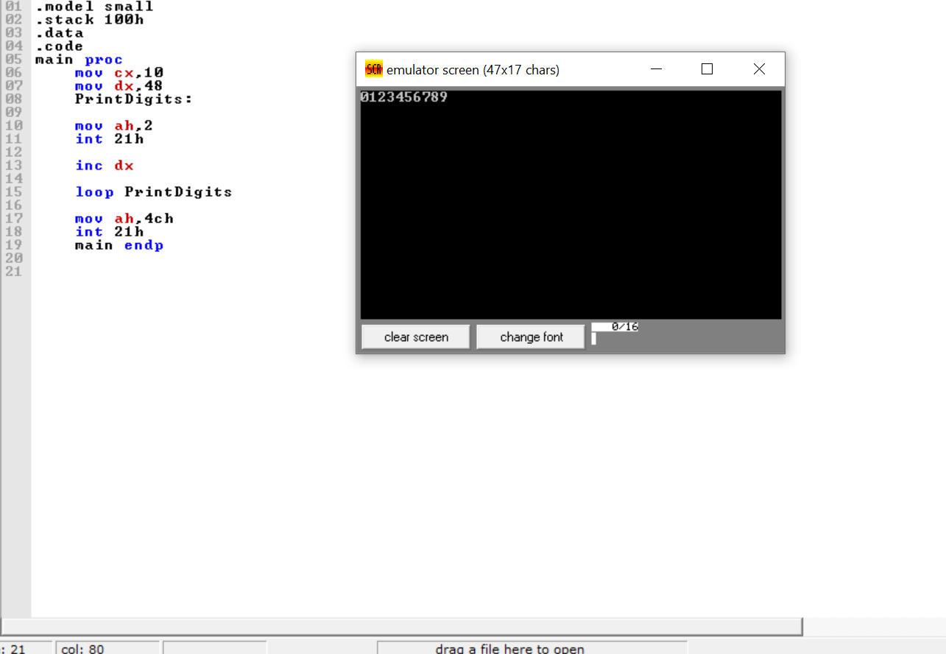

Example code 2:

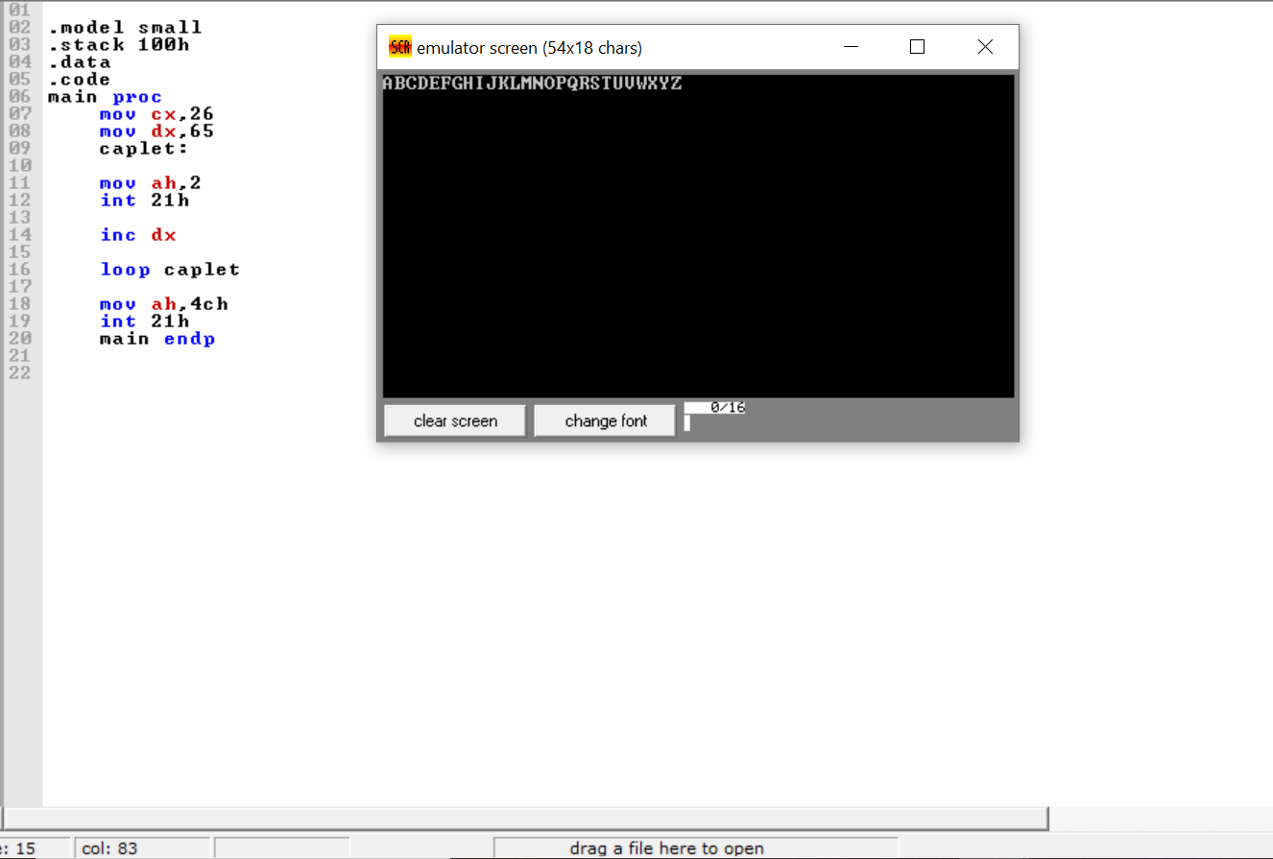

Task no1:

Q: print small letters from a to z

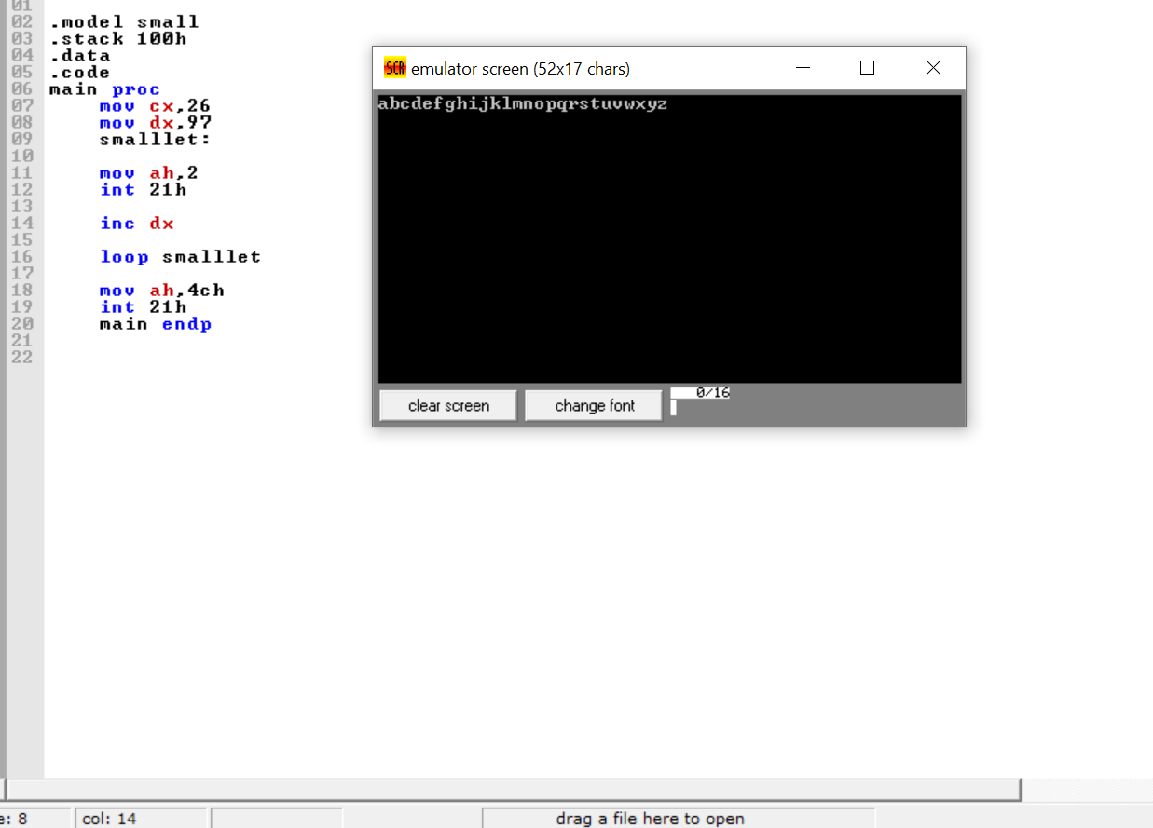

Task no2:
Q: Addition 0 to3
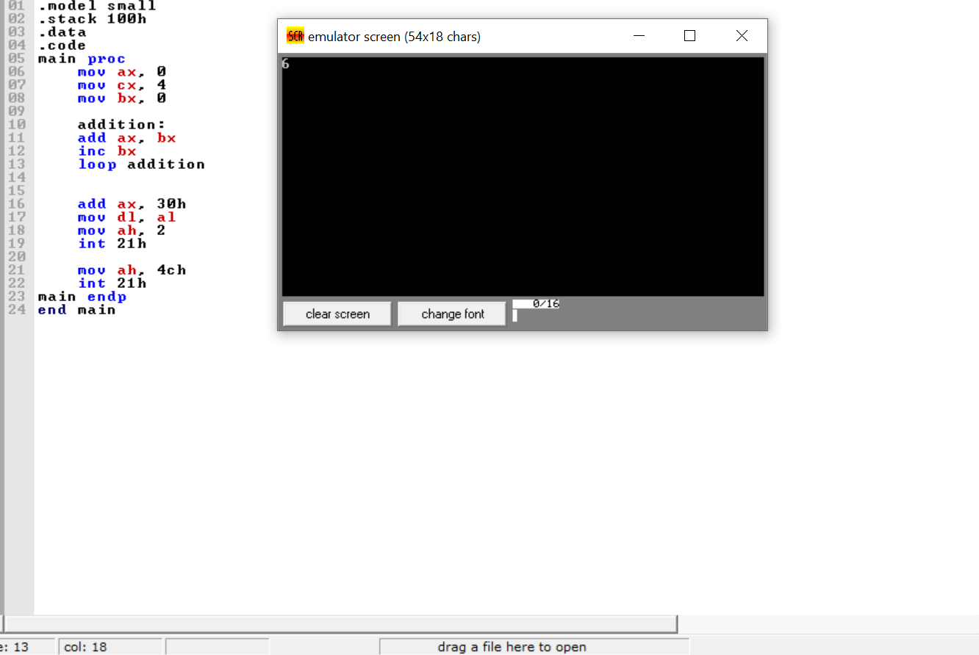

Task no.3:
Q: Print odd number(0-10)

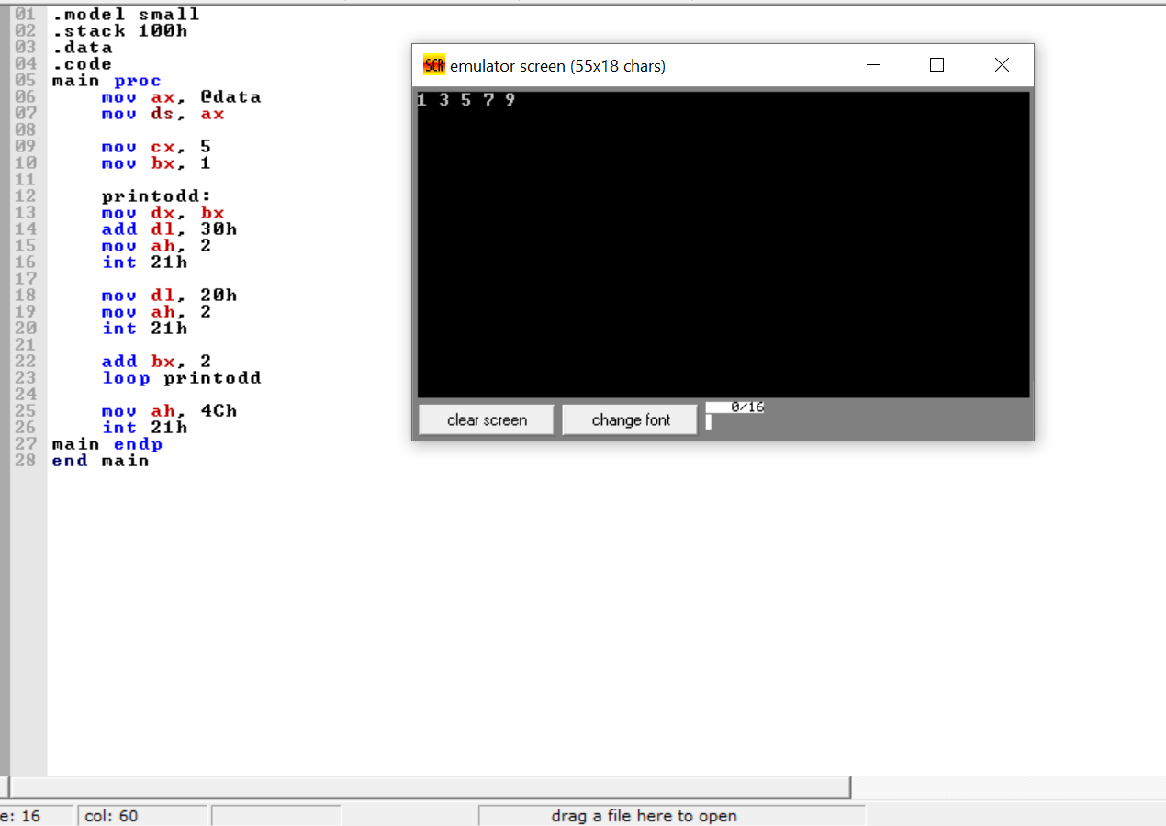

Task no.5:
Q: print the sequence a e i m q u y
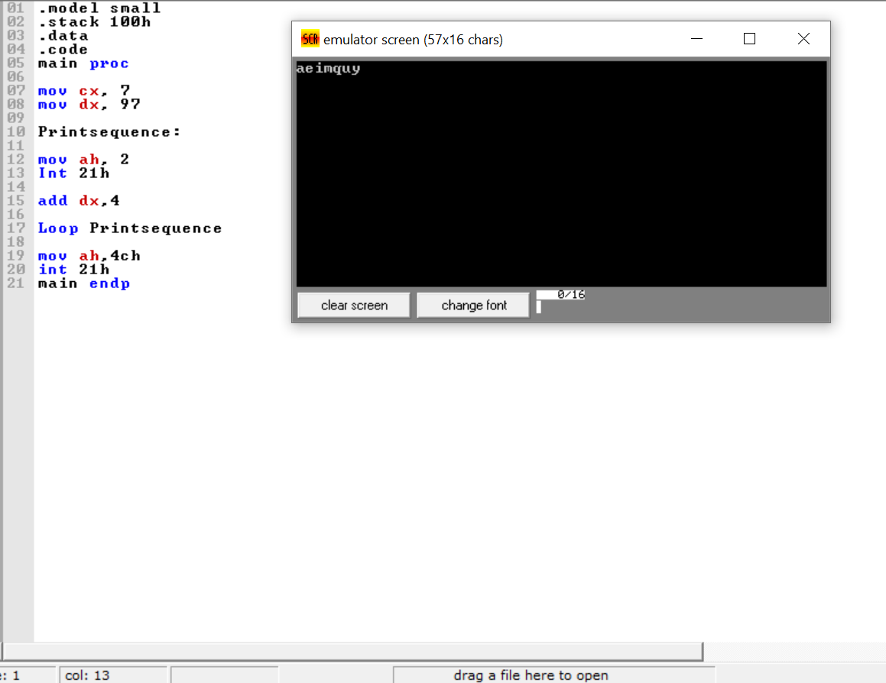

Task no.4:

Q: write a program that take an input from user ‘n’ and print your name ‘n’ times

